* **User Manual of Mobile APP**
* **Mobile APP (Android): -**

App Installation Steps-

1. Click on .apk file
2. Click on Install button

* **Mobile APP Login**

App Login Steps-

1. Open app

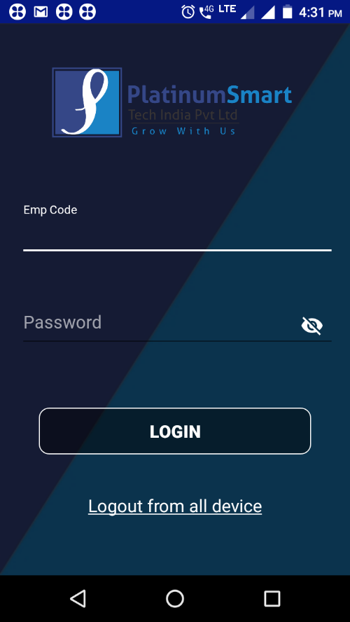

1. Enter Emp Code
2. Enter Password
3. Click on **LOGIN** button

* **LOGOUT FROM OTHER DEVICE (If user already logged in to another device)**

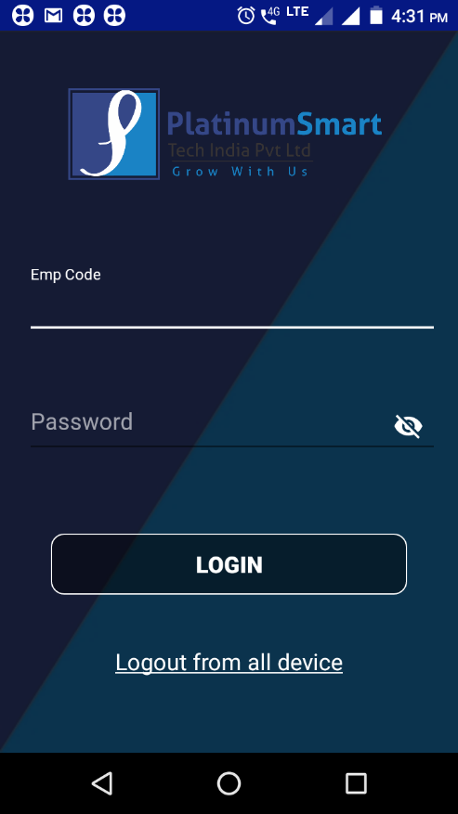

Steps of Logout app from another device-

1. Click on “Logout from all device” link

2. Enter Emp Code

3. Enter Password

4. Click on LOGOUT button

* **Profile:**
* Click on Profile tab
* Pick up executive can see the profile details i.e. Emp Code, First Name, Last Name, Email Id, Work Area and Designation

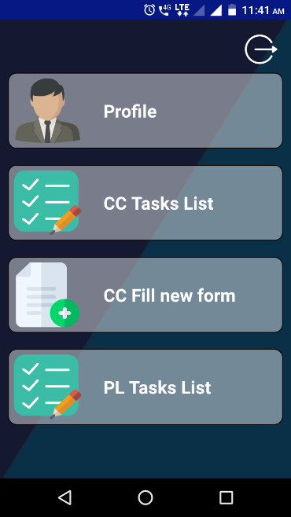

* **CC TASKS LIST:**
* Click on CC Task List

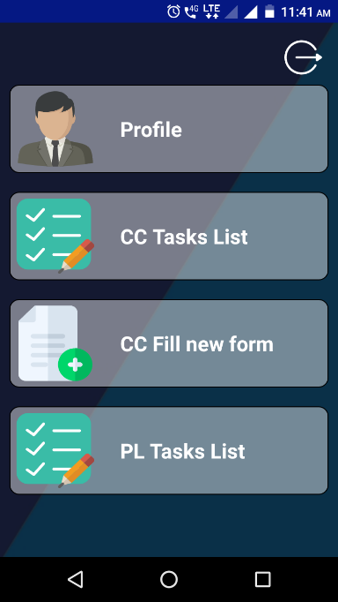

* **TODAY AND PENDING TASKS-**
* Once pick up executive click on the Today and Pending tasks, he can see below details-

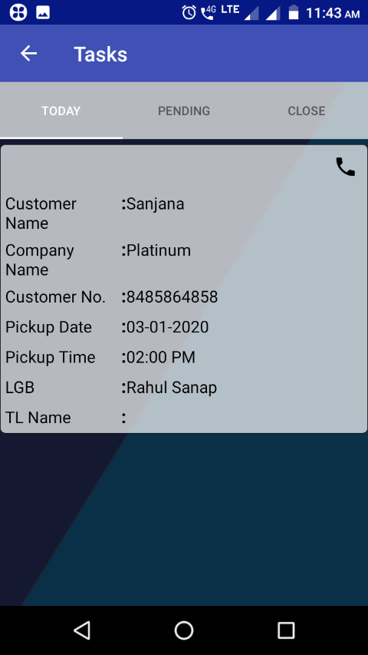 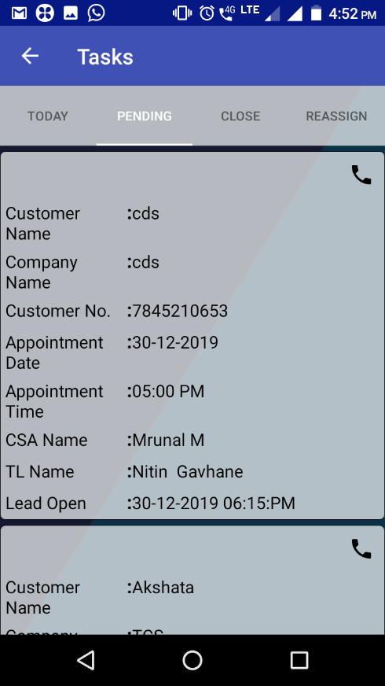

* Once pick up executive click on the Today and Pending tasks, he can see below details-
* Customer Name
* Company Name
* Customer No
* Appointment Date
* Appointment Time
* CSA Name
* TL Name
* Lead Open
* Click on calling icon (if user want to call to the customer)
* Click on the Customer details
* Enter Application No.

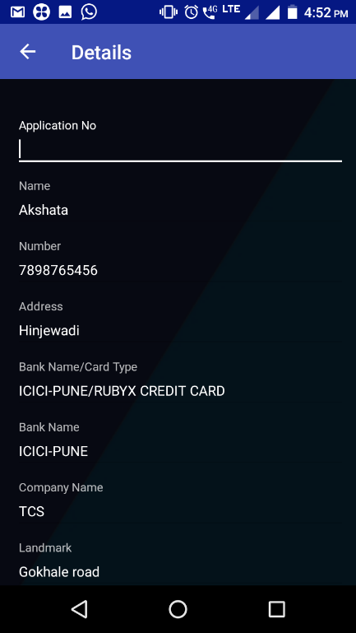

* Click on **Next** button

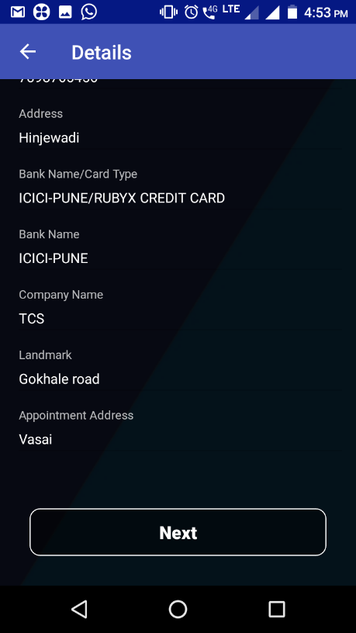

* Go to Document tab

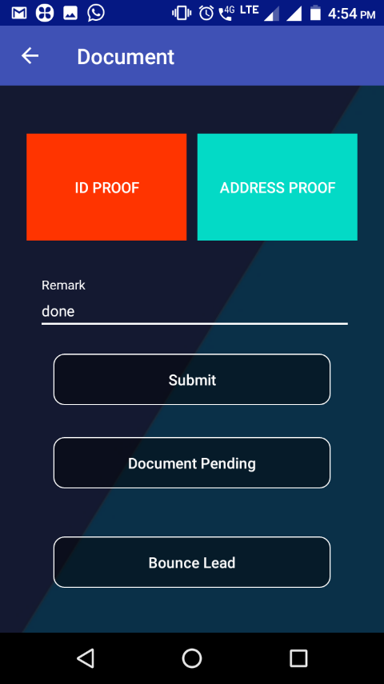

* Select all document list (Only selected document list will display in app which is selected by telecaller from Lead sheet) and click on done
* Click on **Submit** button

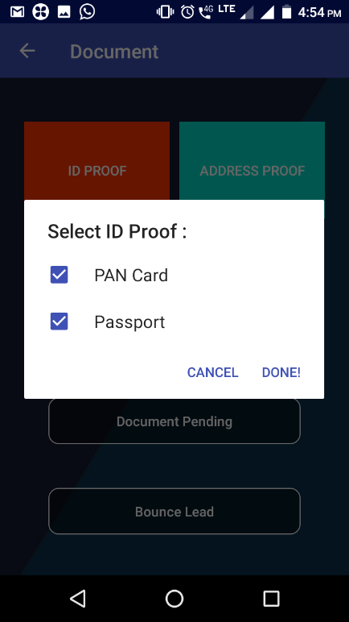 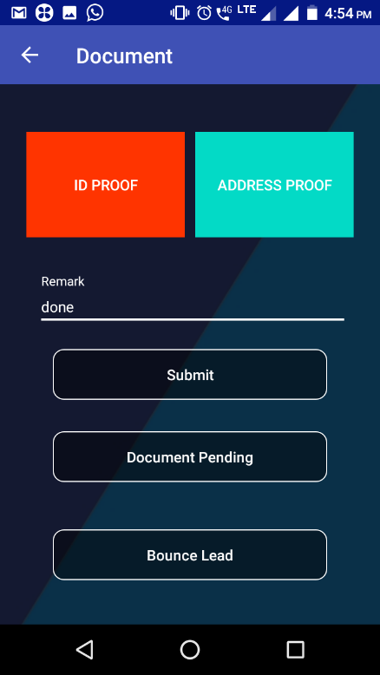

* If any document is pending then enter the **Remark** field and click on **Document Pending** button

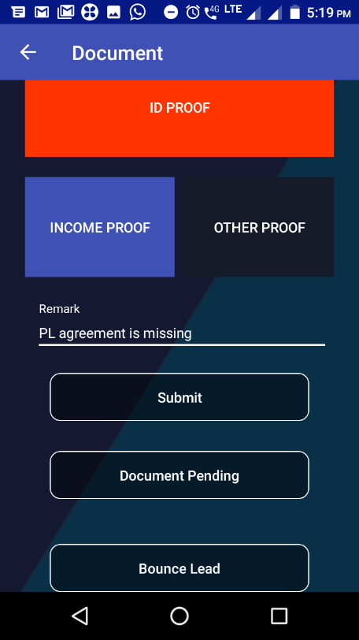

* **CLOSE TASKS-**
* All submitted records will display in the Close Tasks

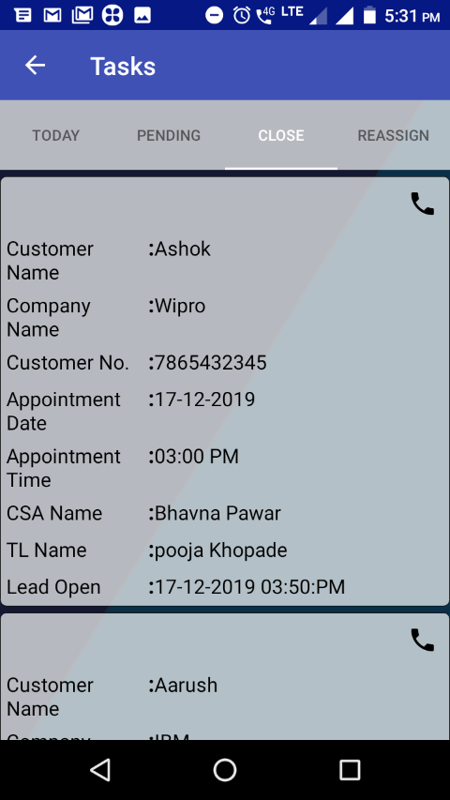

* **REASSIGN TASKS-**
* Click on Reassign Tasks tab
* Click on reassigned details
* Click on Next button

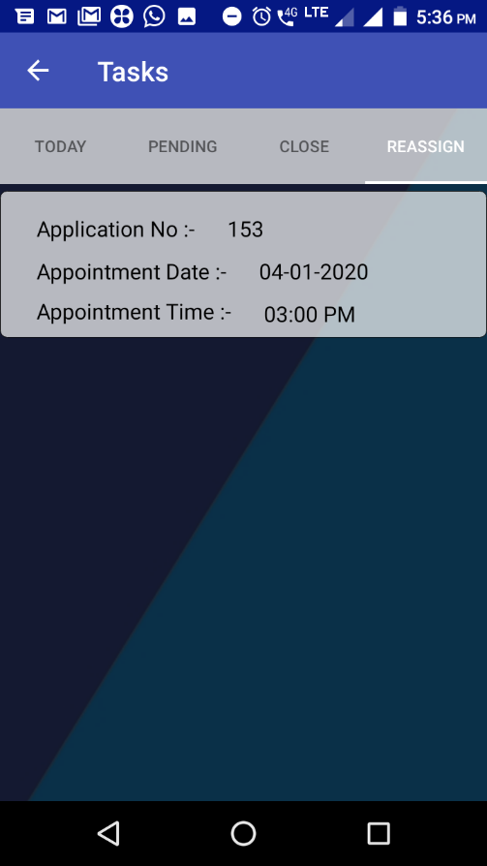 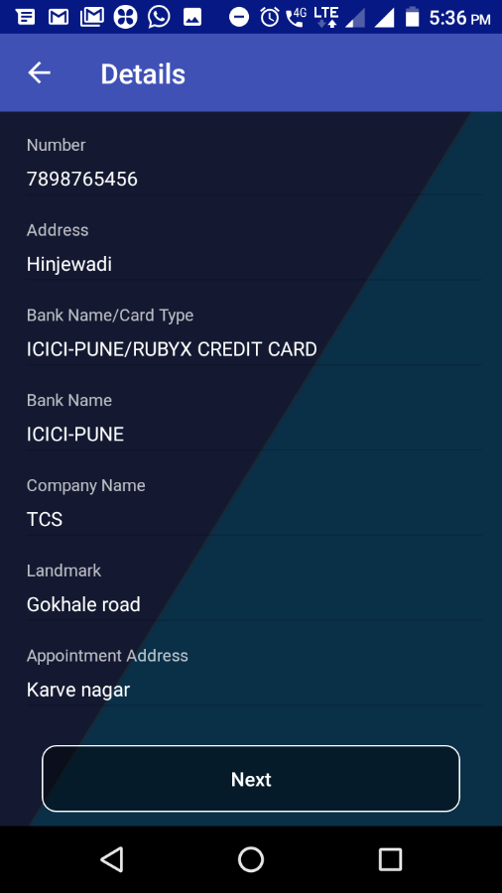

* Select all documents
* Click on Submit button
* If any document is pending then enter remark field and click on Document Pending button

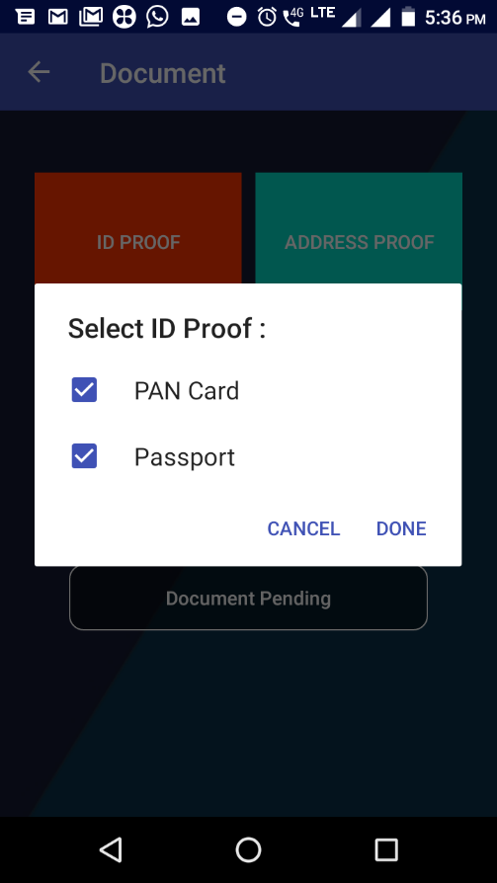 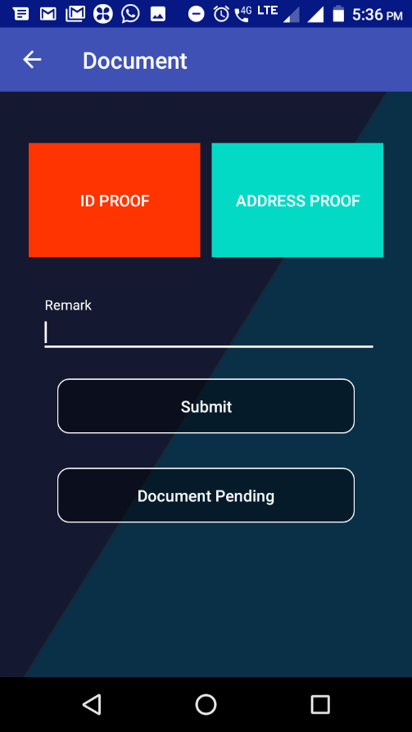

* **CC Fill New Form**

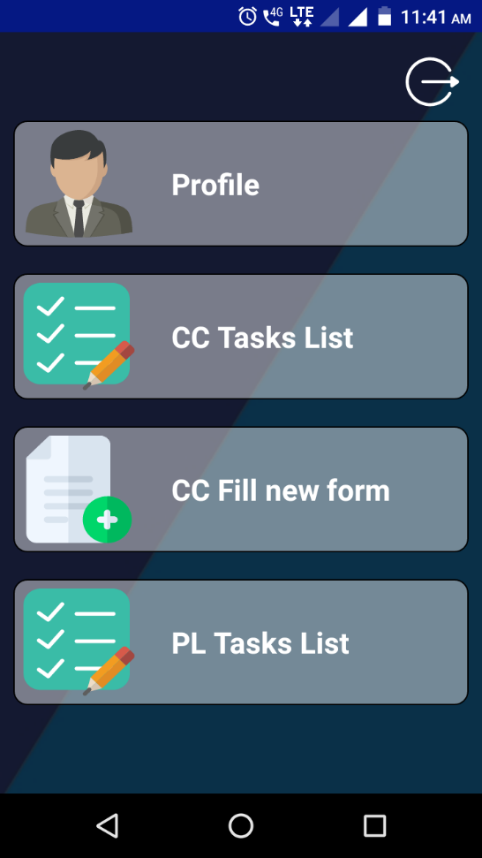 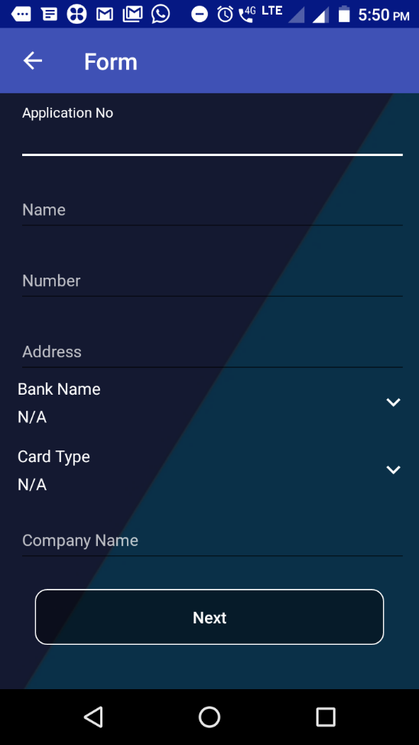

* Click on Fill New Form tab
* Enter Application No.
* Enter Name
* Enter Number
* Enter Address
* Select Bank Name
* Select Card Type
* Enter Company Name
* Click on Next button

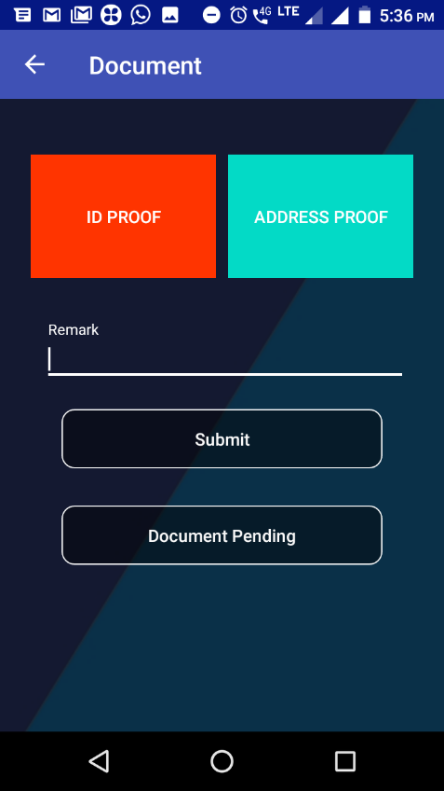 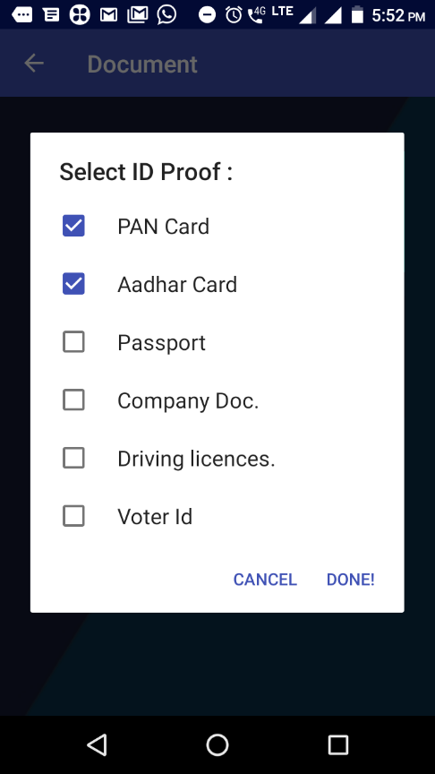

* Select document list and click on done button
* Enter remark field if user not selecting any documents
* Click on Submit button
* **PL Task List:**
* **Step 1:** Click on PL Tasks List

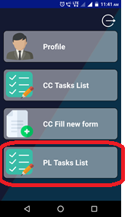

* **Step 2:** Click on Today or Pending
* **TODAY AND PENDING TASKS-**

If employee generate one lead and click on file pick up or agreement pickup then there is option to select pick up executive name. Then selected pick up executive got details of customer in today and pending task. If pick up date is today then only that lead displayed in today tab and today as well as future pick-ups assigned to that pick up executive are displayed in pending task.

* Once pick up executive click on the Today and Pending tasks, he can see below details-
* Customer Name
* Company Name
* Customer No
* Pickup Date
* Pickup Time
* LGB (name of Lead generated by)
* TL Name

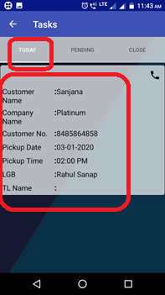 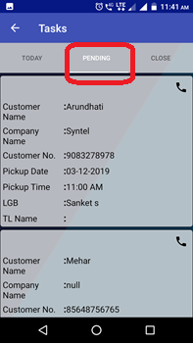

* Click on calling icon (if user want to call to the customer)
* Click on the Customer details, then you are able to see below customer details:
* LOS No
* Name
* Number
* Address
* Company Name
* Landmark
* Pickup Data
* Pickup Time
* Lead Generated by
* Team Lead
* Type (File pickup or Agreement pickup)
* **Step 3:** Click on Next

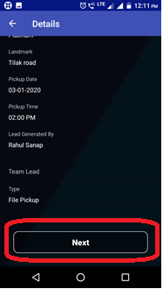

Document screen is displayed, like below attachment

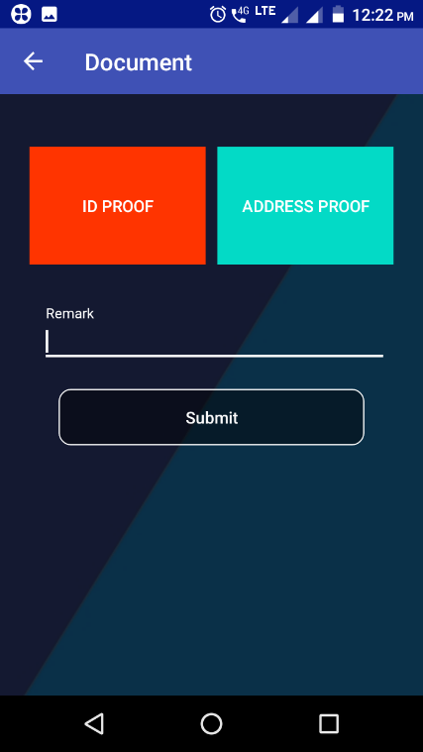

* **Step 4:** Select all document list (Only selected document list will display in app which is selected by tele caller from Lead sheet) and click on done

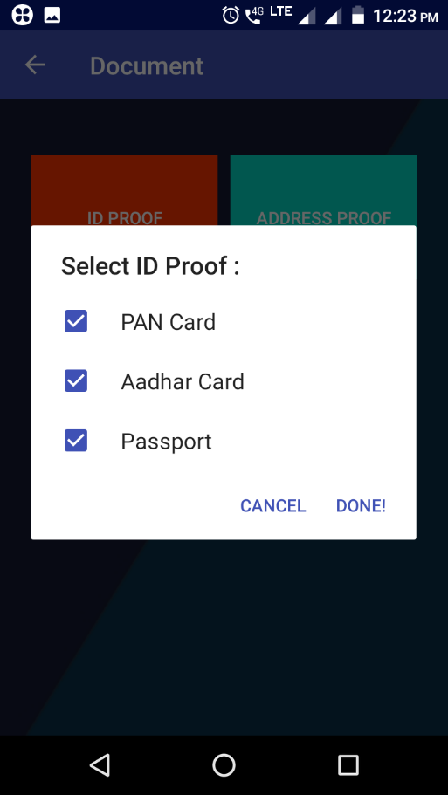 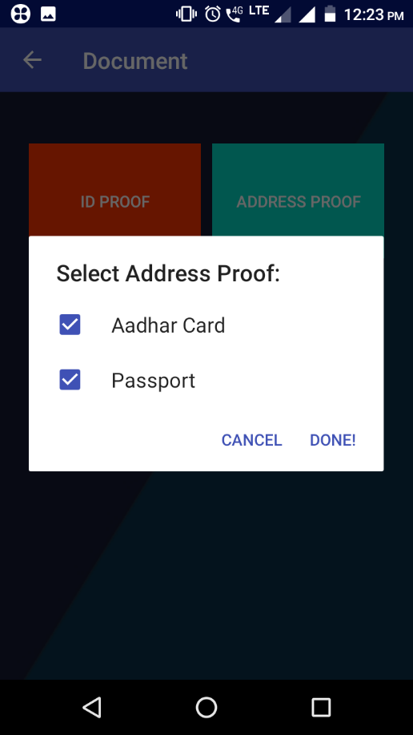

* **Step 5:** Click on **Submit** button
* **Step 6:** If any document is pending then enter the **Remark** field and click on **submit** button

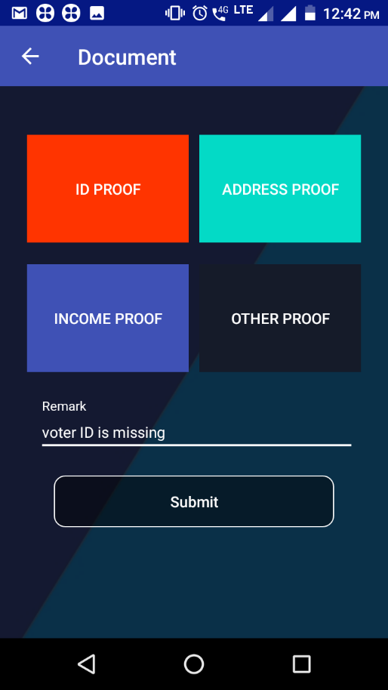

After submitting document of particular customer then details of that customer are goes to close tab and disappear from today and pending tab.

